- Food
- DIY
- Holidays
- Entertaining
- Home
- Life & Style
- Shop
- Enter Our Dream Vacation Sweepstakes!

  - Martha's Blog
  - Weddings
- Magazine
- Sign In
Sign Up
Include Images
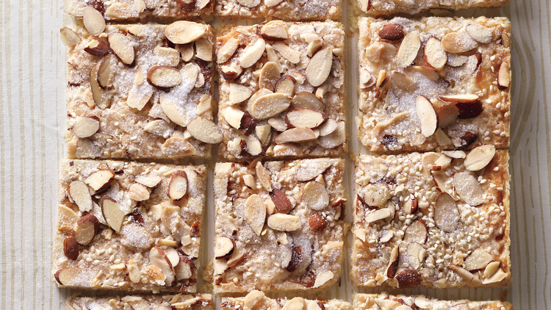

Gingered Sesame-Almond Shortbread Bark
The bark can be made up to three days ahead and stored at room temperature.
1 hour 30 mins Makes 24 cookies
Total Time Prep Yield

Ingredients
- 1 3/4 sticks cold unsalted butter, cut into pieces, plus more, softened, for brushing pan
- 2 1/4 cups all-purpose flour
- 1 teaspoon ground ginger
- 1/4 teaspoon coarse salt
- 1/2 teaspoon baking powder
- 3/4 cup sugar
- 1 large egg white, lightly beaten
- 1 cup sliced almonds
- 2 tablespoons sesame seeds

Directions
- 1. Brush bottom and sides of a 10-by-15-inch baking pan with softened butter. Line pan with parchment, with a 2-inch overhang on each long side, then brush parchment with more butter. Preheat oven to 350 degrees.
- 2. Place flour, ginger, salt, baking powder, and 1/2 cup sugar in a food processor; pulse to combine. Add cold butter and pulse until dough just comes together. Scatter evenly in pan, then press firmly to flatten. Brush dough with egg white to moisten, then scatter with almonds, sesame seeds, and remaining 1/4 cup sugar in alternating even layers.
- 3. Bake until golden, about 35 minutes. Transfer bark on parchment to a cutting board. Immediately cut into 24 pieces (4 strips on short side, 6 on long side), then transfer to a wire rack and let cool completely. Bark can be made 3 days ahead and stored at room temperature.
© Copyright 2018, Martha Stewart Living Omnimedia, Inc. All rights reserved.

